**Home_Desktop**

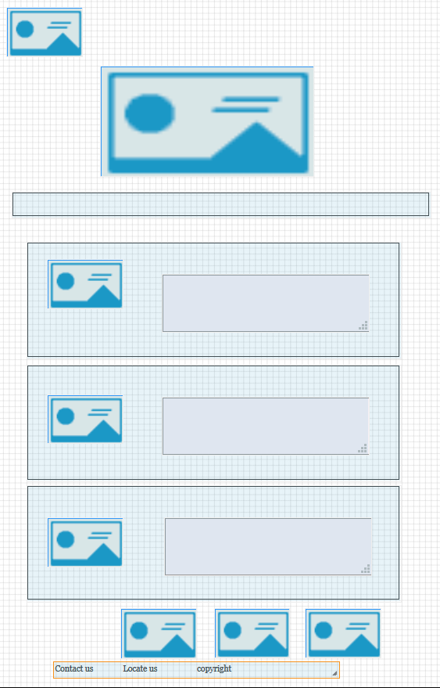

**Home_Tablet**

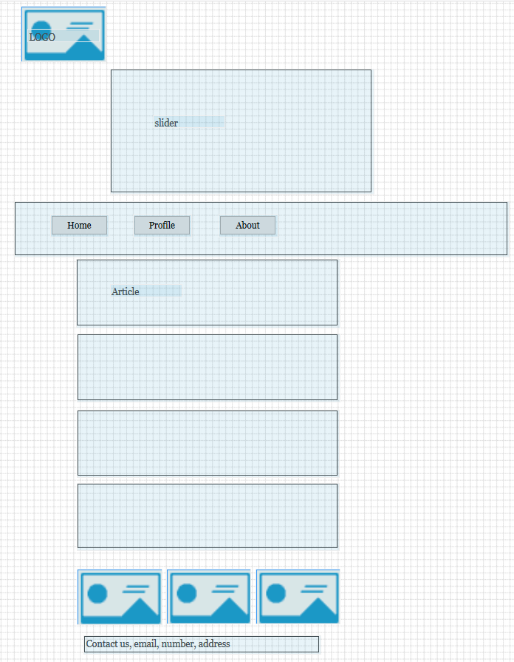

**Home_Mobile**

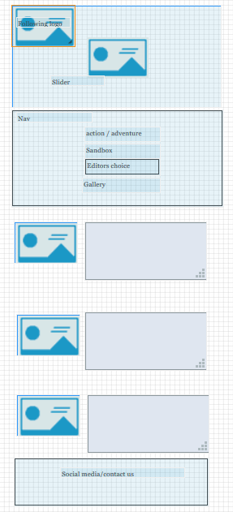

**Contact_Desktop**

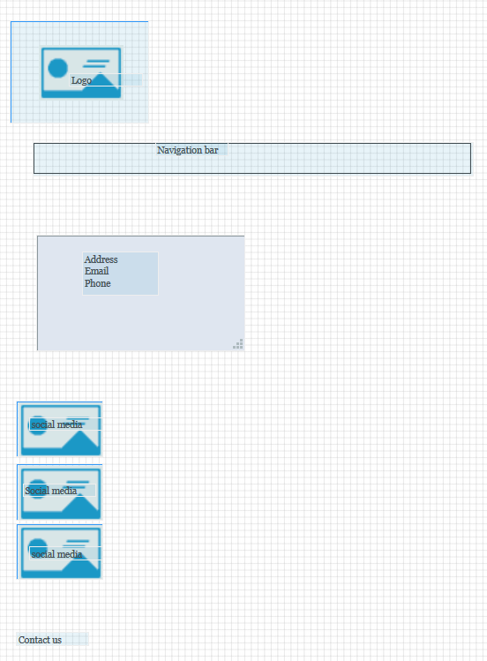

**Contact_Tablet**

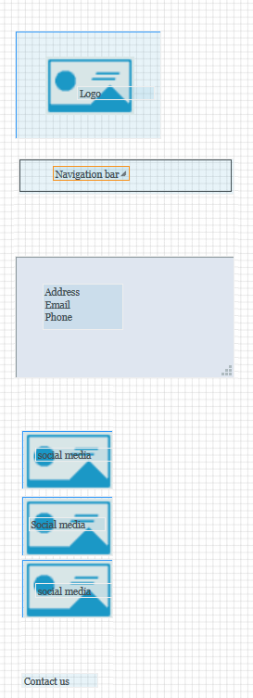

**Contact_Mobile**

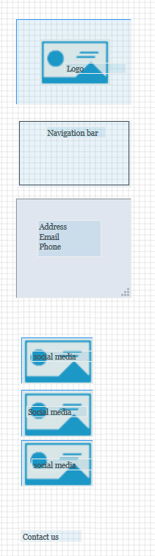

**Gallery_Desktop**

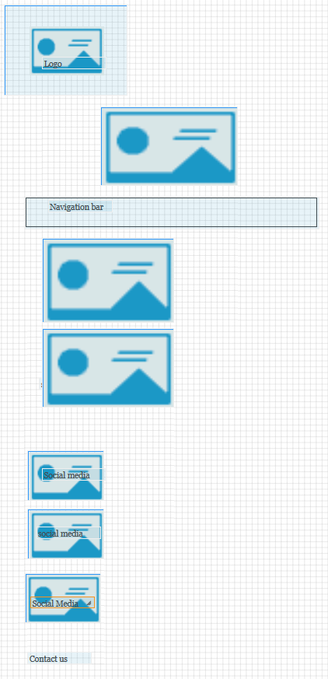

**Gallery_Tablet**

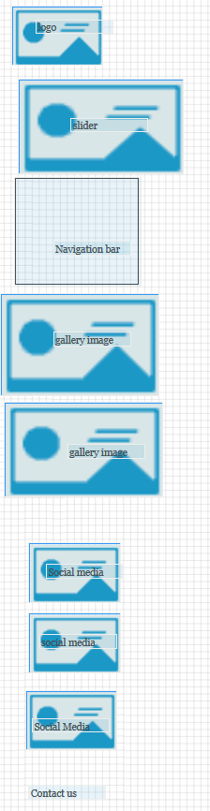

**Gallery_Mobile**

